# Assignment 3

Clone the game-of-life project from git repo. Compile and deploy gameoflife project on slave 1 and slave 2. Do this with 2 different jobs.

## Deploying app on slave 1

## Step 1: Created 1 JM and 2 Slaves

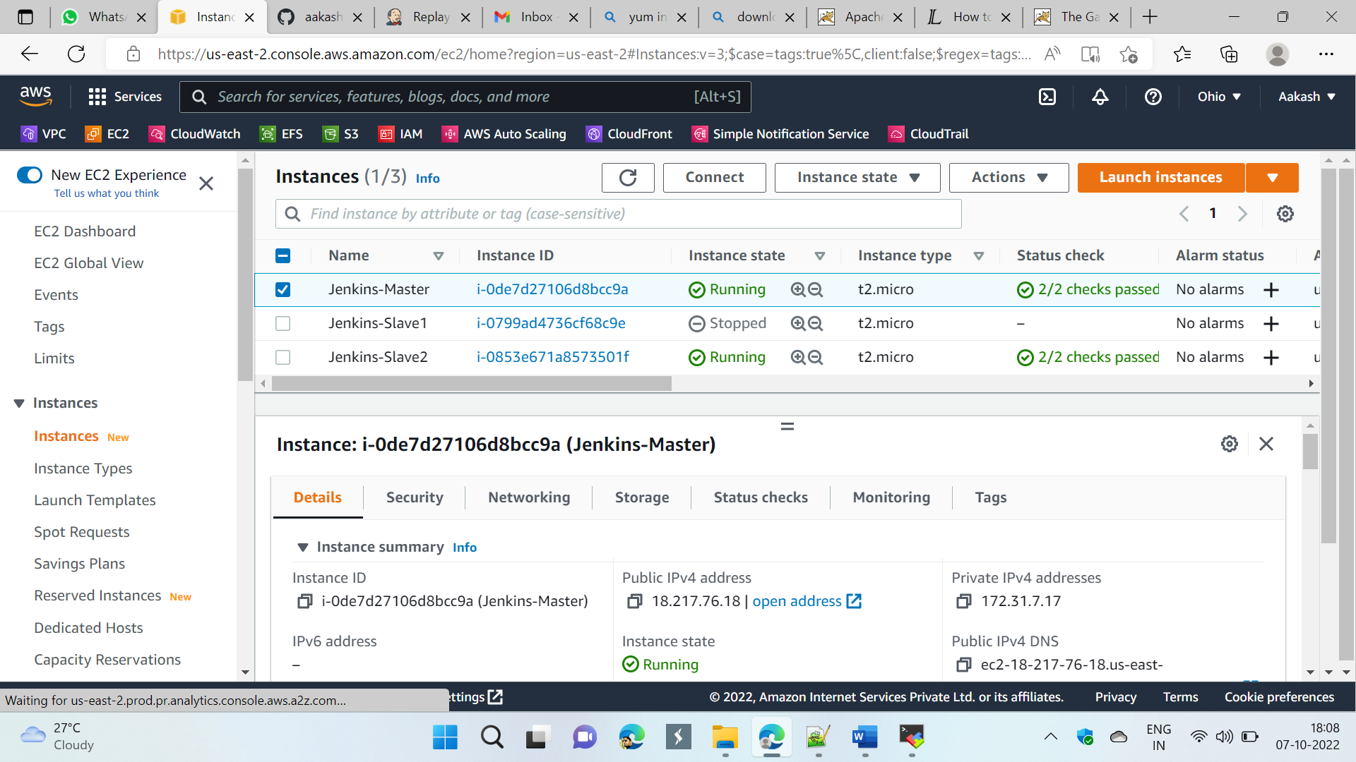

## Pipeline:

pipeline {

agent {

label {

label "Slave-1"

customWorkspace "/mnt/jenkins-slave1/"

}

}

stages {

stage ('git-install-clone-slave-1') {

steps {

sh "sudo yum install git -y"

sh "sudo rm -rf *"

sh "sudo git clone https://github.com/aakashchavhan/game-of-life.git"

}

}

stage ('tomcat1-install-start') {

steps {

dir ('/mnt/jenkins-slave1/server/') {

sh "sudo rm -rf apache-tomcat-9.0.67*"

sh "sudo wget https://dlcdn.apache.org/tomcat/tomcat-9/v9.0.67/bin/apache-tomcat-9.0.67.zip"

sh "sudo unzip apache-tomcat-9.0.67.zip"

sh "sudo chmod -R 777 /mnt"

sh "sudo bash /mnt/jenkins-slave1/server/apache-tomcat-9.0.67/bin/shutdown.sh"

sh "sudo bash /mnt/jenkins-slave1/server/apache-tomcat-9.0.67/bin/startup.sh"

}

}

}

stage ('maven-install') {

steps {

dir ('/mnt/jenkins-slave1/build-tool/') {

sh "sudo rm -rf apache-maven-3.8.6*"

sh "sudo wget https://dlcdn.apache.org/maven/maven-3/3.8.6/binaries/apache-maven-3.8.6-bin.zip"

sh "sudo unzip apache-maven-3.8.6-bin.zip"

sh "sudo rm -rf apache-maven-3.8.6-bin.zip"

}

}

}

stage ('build-app') {

steps {

dir ('/mnt/jenkins-slave1/game-of-life') {

sh "sudo mvn install"

}

}

}

stage ('deploy-app-slave1') {

steps {

dir ('/mnt/jenkins-slave1/server/apache-maven-3.8.6/webapps/') {

sh "sudo cp -r /mnt/jenkins-slave1/game-of-life/gameoflife-web/target/gameoflife.war /mnt/jenkins-slave1/server/apache-tomcat-9.0.67/webapps/"

}

}

}

}

}

## Step 2: Created Job

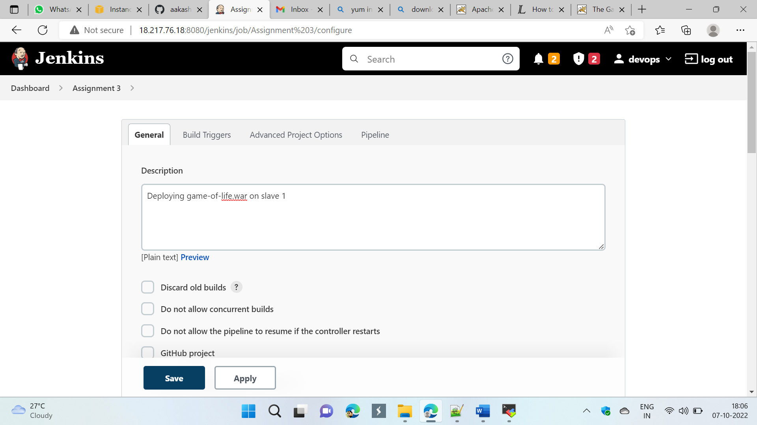

## Step3: Added pipeline

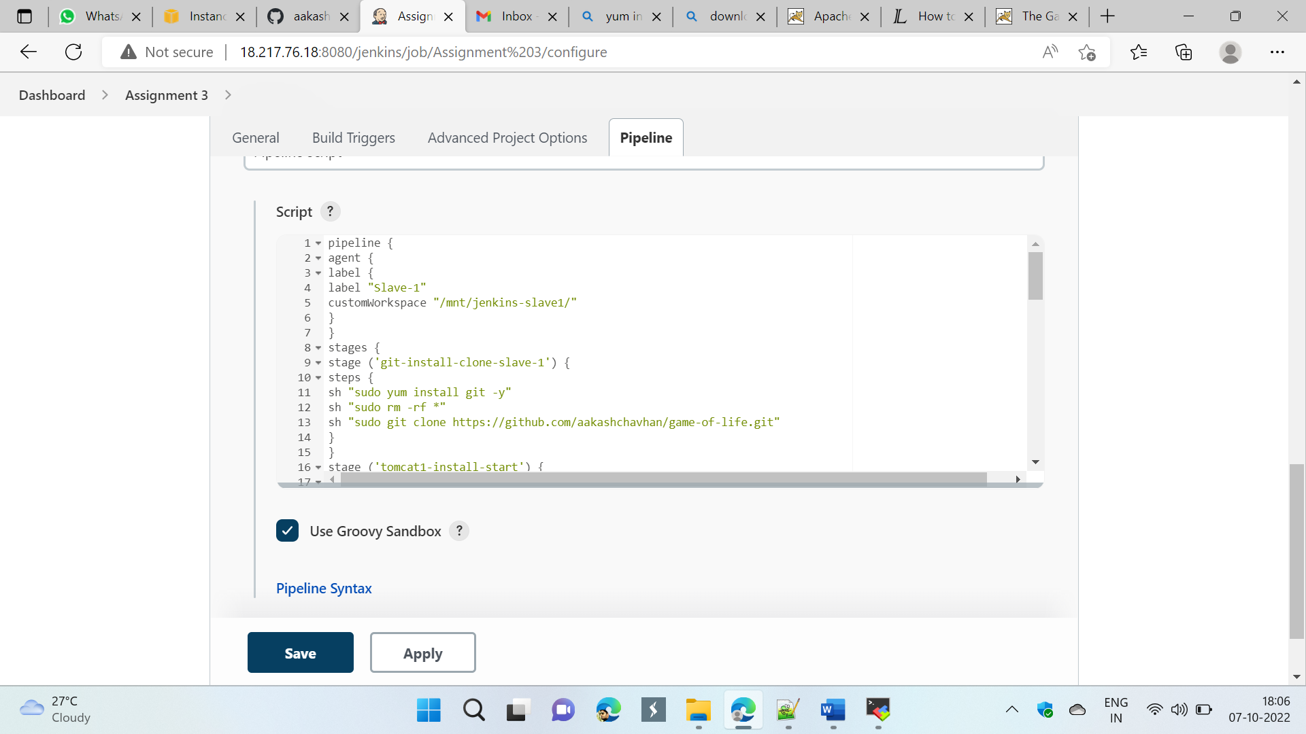

## Step 4: Build Now

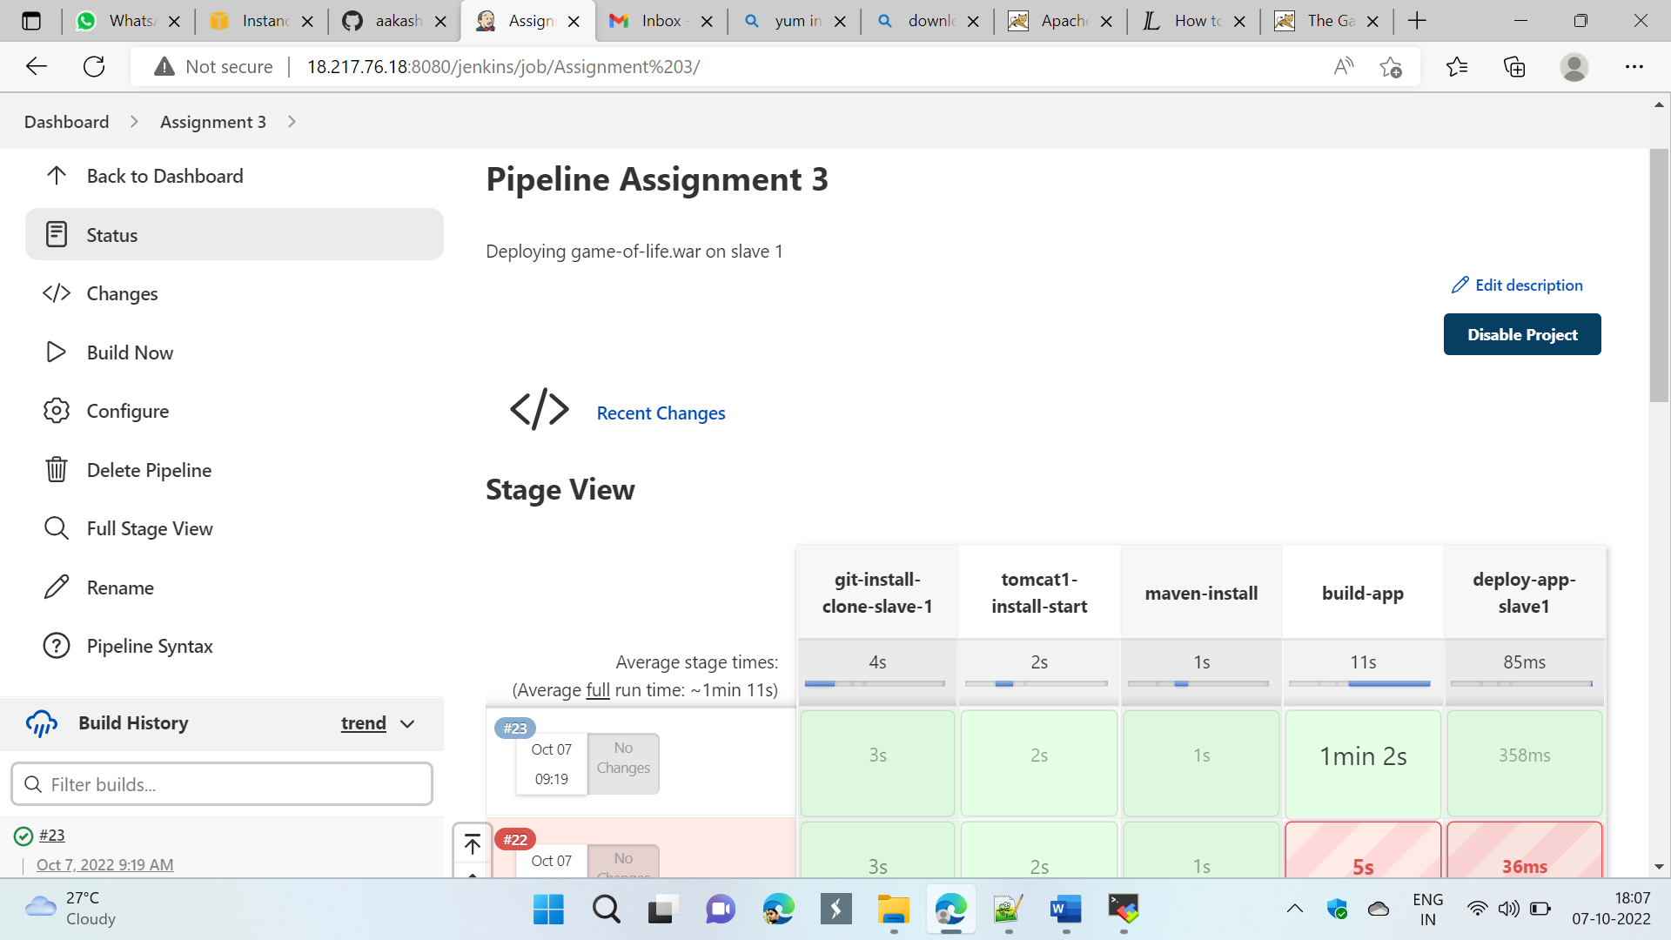

## Step 5: Copy paste public-ip:8080/gameoflife/ in browser

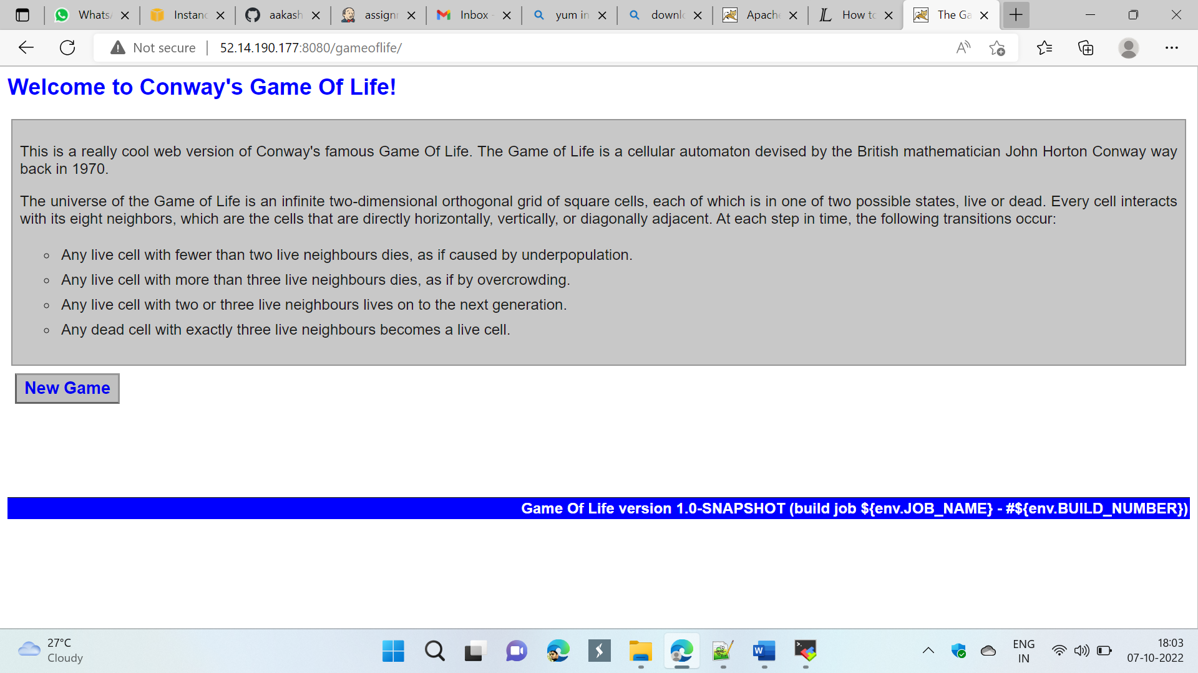

## Deploying app on slave 2

## Step 1: Created 1 JM and 2 Slaves



## Pipeline

pipeline {

agent {

label {

label "Slave-2"

customWorkspace "/mnt/jenkins-slave2/"

}

}

stages {

stage ('install-clone-git2') {

steps {

sh "sudo rm -rf game-of-life*"

sh "sudo yum install git -y"

sh "sudo git clone https://github.com/aakashchavhan/game-of-life.git"

}

}

stage ('install-maven2') {

steps {

dir ('/mnt/jenkins-slave2/build-tool/') {

sh "sudo yum install maven -y"

}

}

}

stage ('install-tomcat2') {

steps {

dir ('/mnt/jenkins-slave2/server/') {

sh "sudo rm -rf apache-tomcat-9.0.68*"

sh "sudo wget https://dlcdn.apache.org/tomcat/tomcat-9/v9.0.68/bin/apache-tomcat-9.0.68.zip"

sh "sudo unzip apache-tomcat-9.0.68.zip"

sh "sudo chmod -R 777 /mnt"

}

}

}

stage ('build-app2') {

steps {

dir ('/mnt/jenkins-slave2/game-of-life/') {

sh "sudo bash mvn install"

}

}

}

stage ('deploy-app2') {

steps {

dir ('/mnt/jenkins-slave2/game-of-life/gameoflife.web/target/') {

sh "sudo cp -r /mnt/jenkins-slave2/game-of-life/gameoflife-web/target/gameoflife.war /mnt/jenkins-slave2/server/apache-tomcat-9.0.68/webapps/"

}

}

}

stage ('restart-tomcat2') {

steps {

dir ('/mnt/jenkins-slave2/server/apache-tomcat-9.0.68/bin') {

sh "sudo bash ./shutdown.sh"

sh "sudo bash ./startup.sh"

}

}

}

}

}

## Step 2: Created a Job

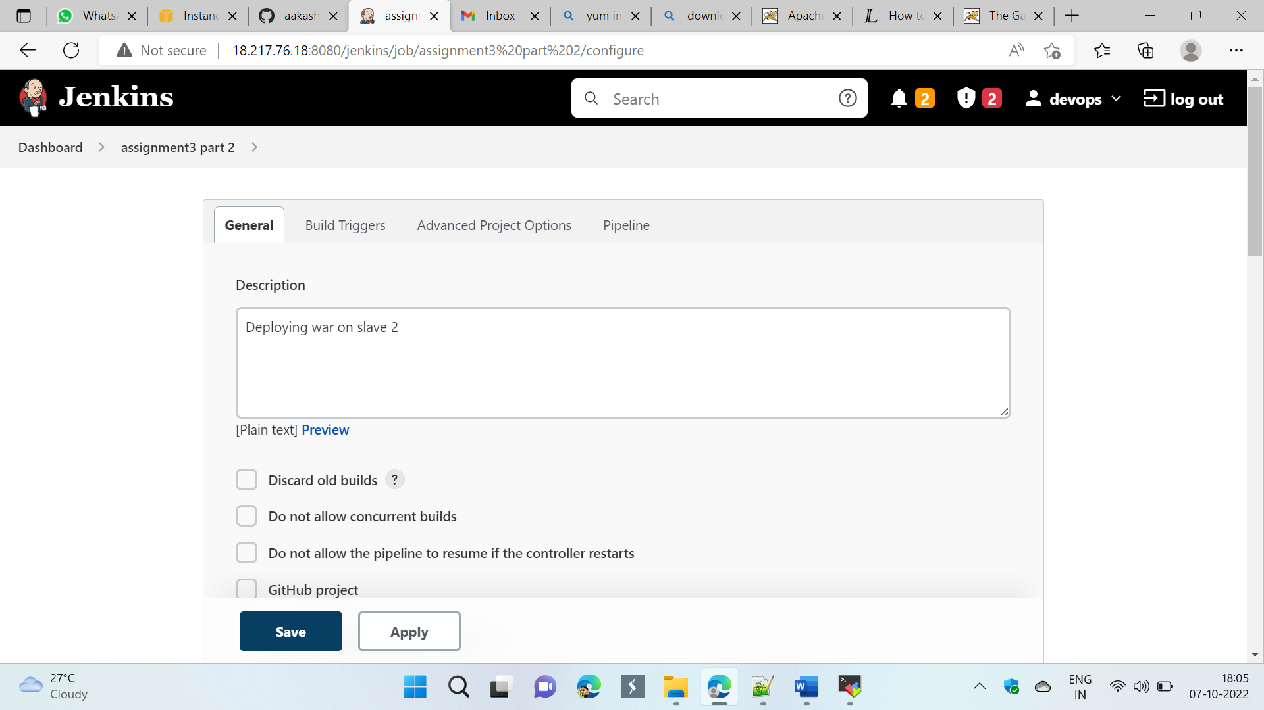

## Step 3: Added pipeline

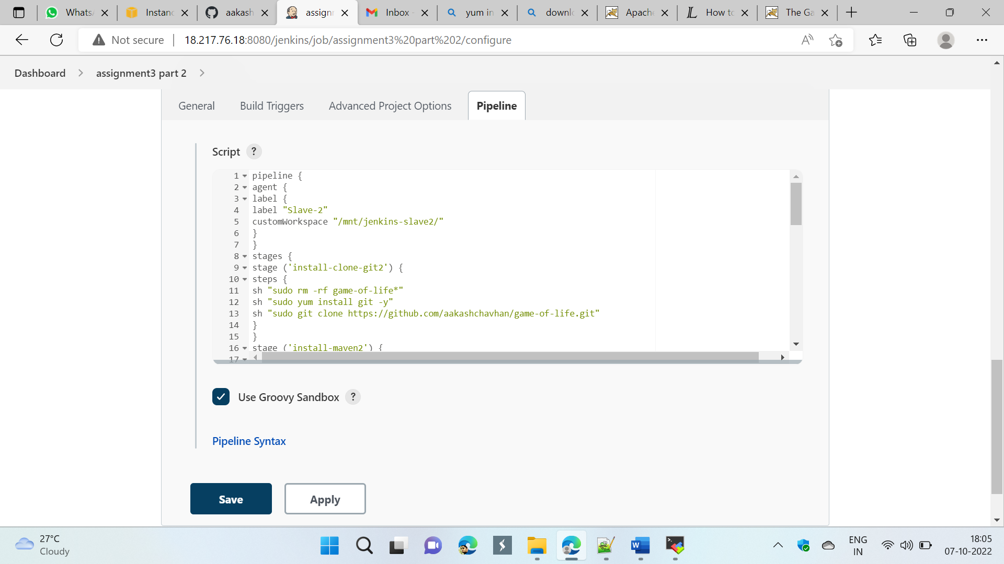

## Step4: Build Now

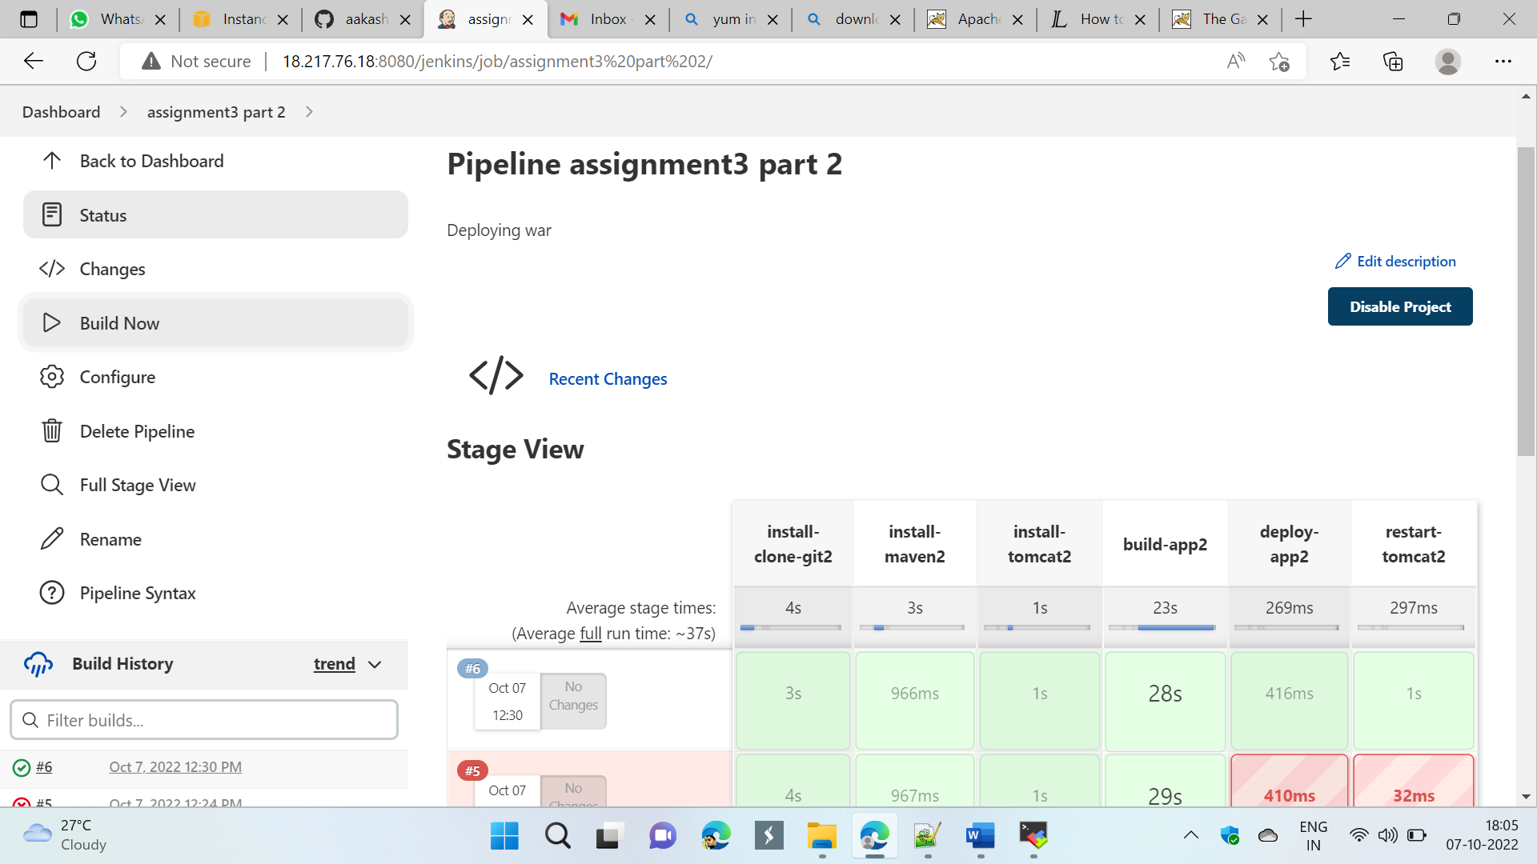

## Step 5: Copy paste public-ip:8080/gameoflife/ in browser

